[**https://www.mongodb.com/docs/atlas/getting-started/**](https://www.mongodb.com/docs/atlas/getting-started/) **(DOCUMENTATION)**

**Database As A Service**

**MongoDB ATLAS**

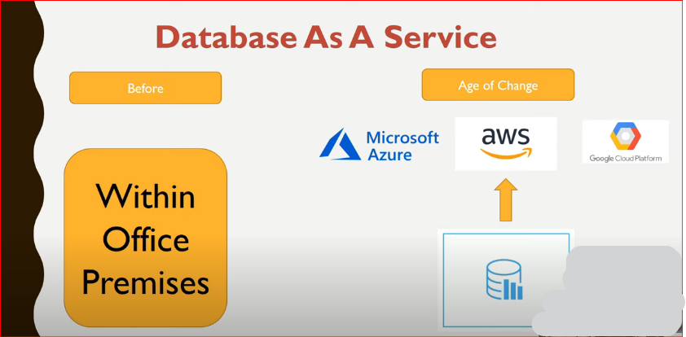

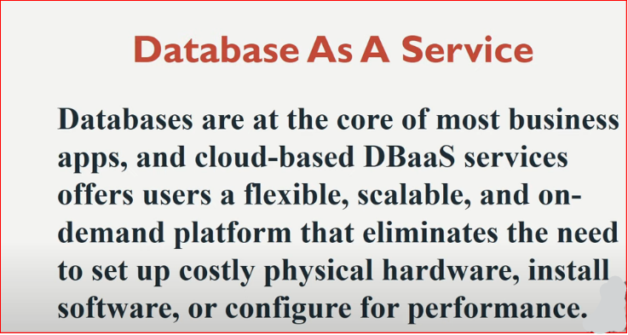

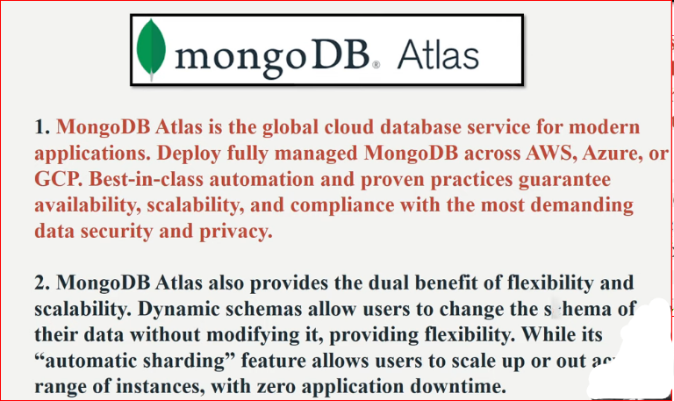

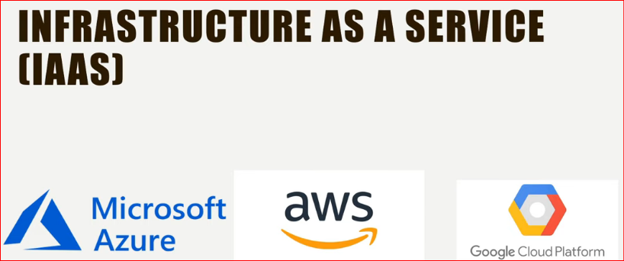

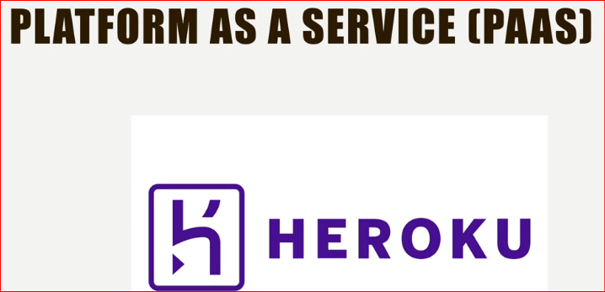

**MongoDB Atlas:**

**Login via below Gmail id: and I have already create one AWS cluster of 512MB free**

* **abc@gmail.com**

**Choose SHARED Cluster of AWS**

* **username: abc & pwd: 123**

**ip: 111.222.333.444**

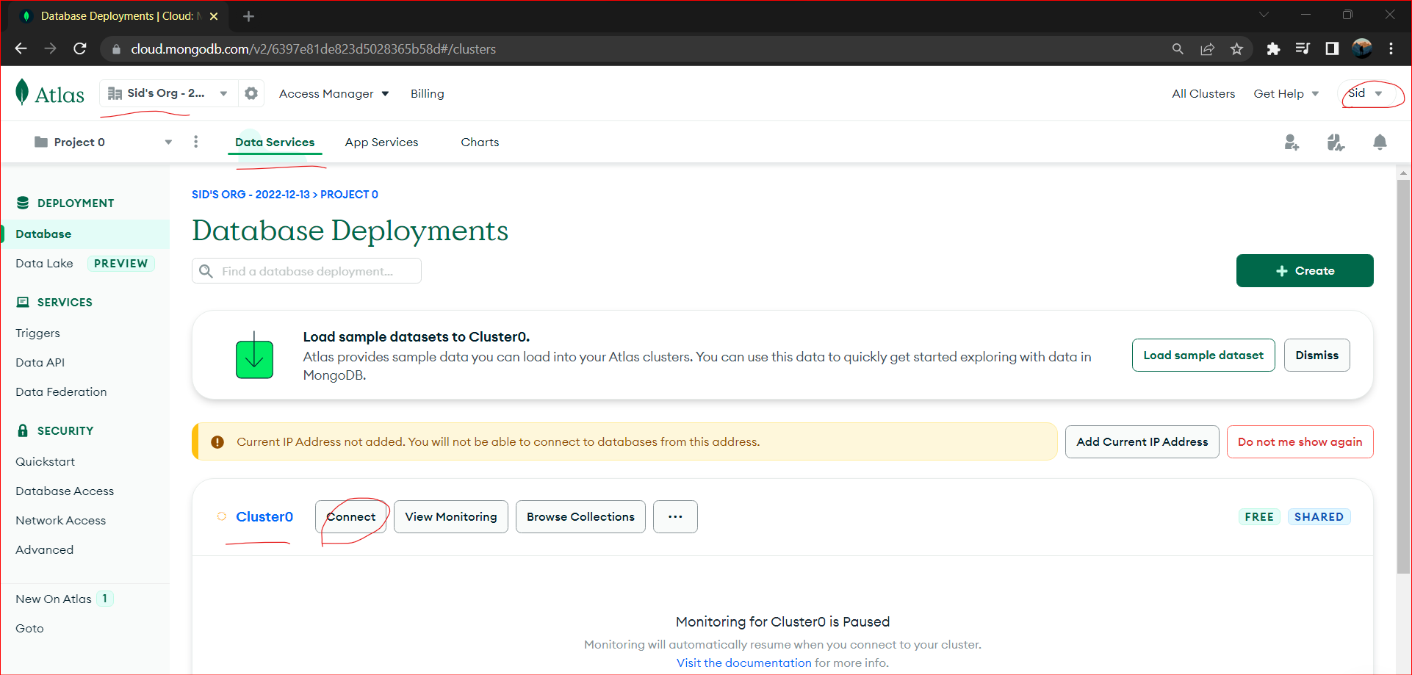

**1st : Click on “ADD to IP address” & then**

**2nd Connect to Cluster using MongoDB Compass**

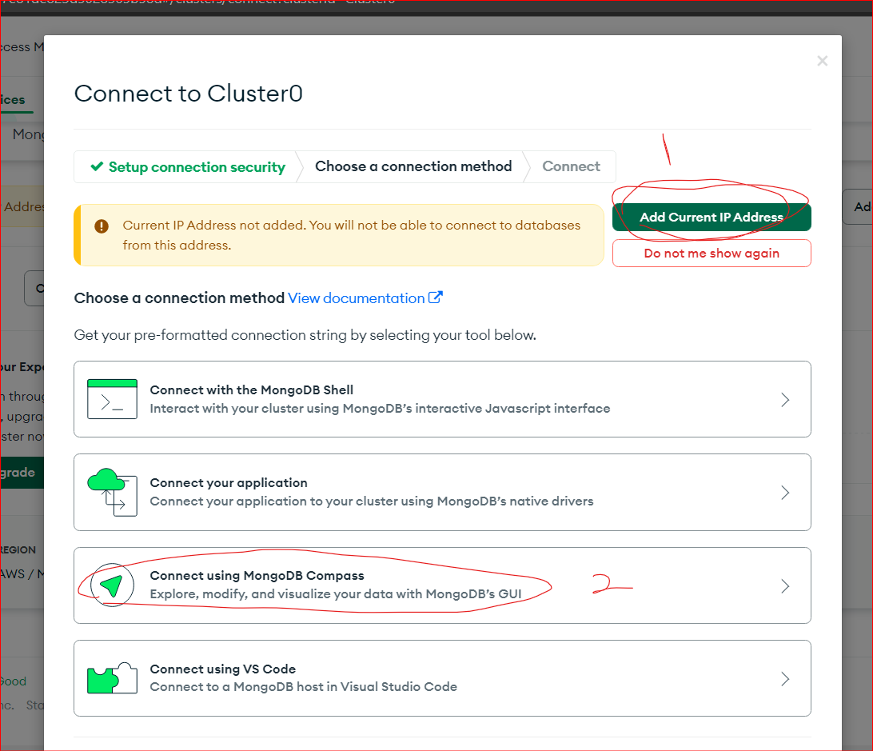

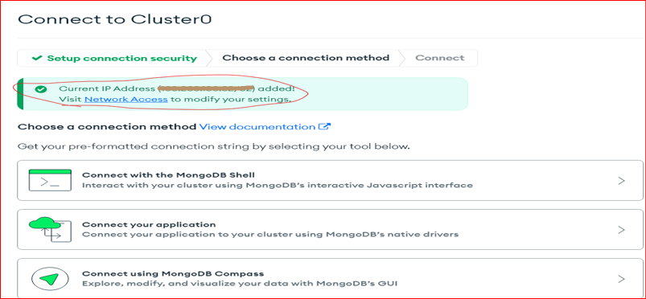

**Choose ‘I have MongoDB compass’ and**

**Copy the Link**

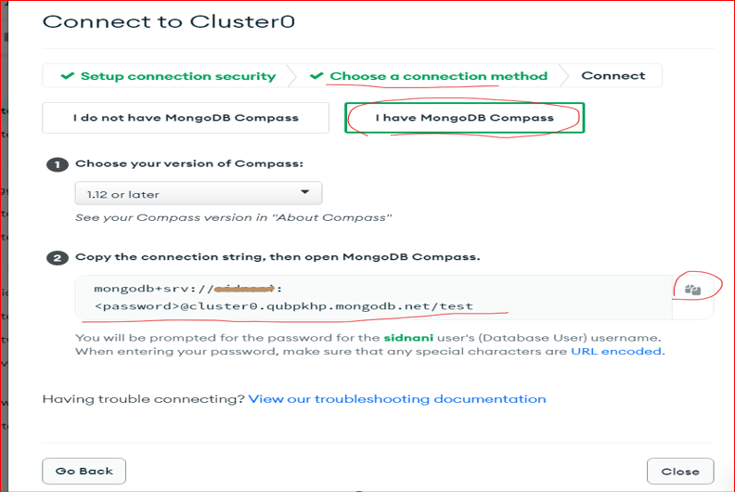

**Open Your MongoDB Compass**

* **Click ‘New Connection’ and Paste the connection string link**

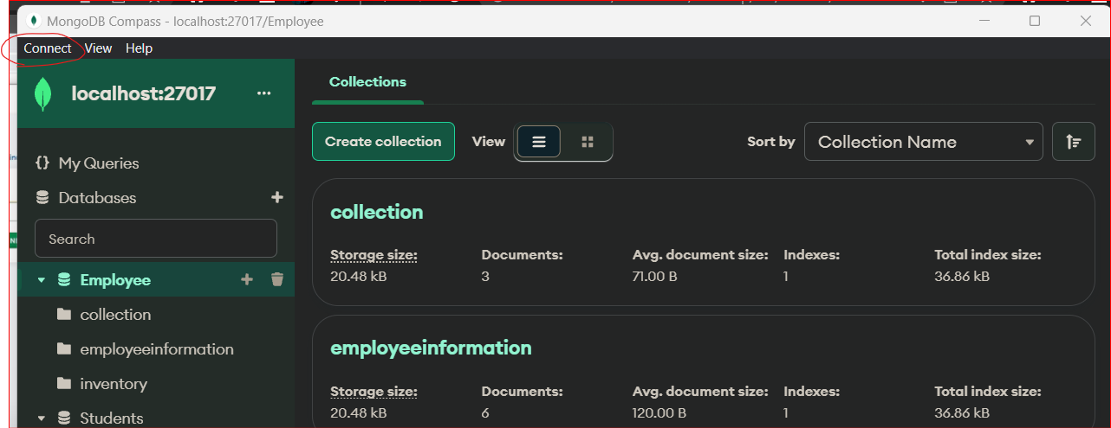

**Paste it**

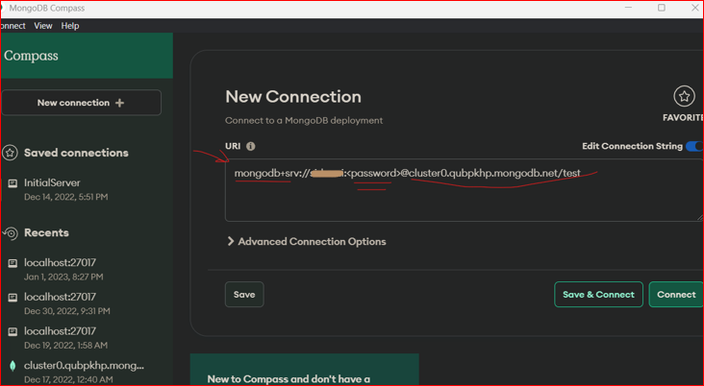

**Replace the password:**

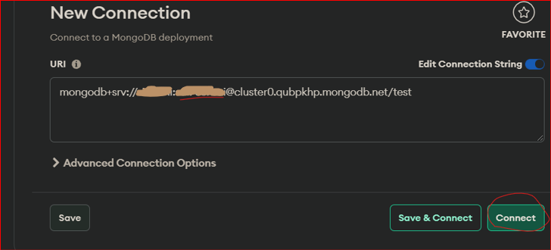

**Connected Successfully:**

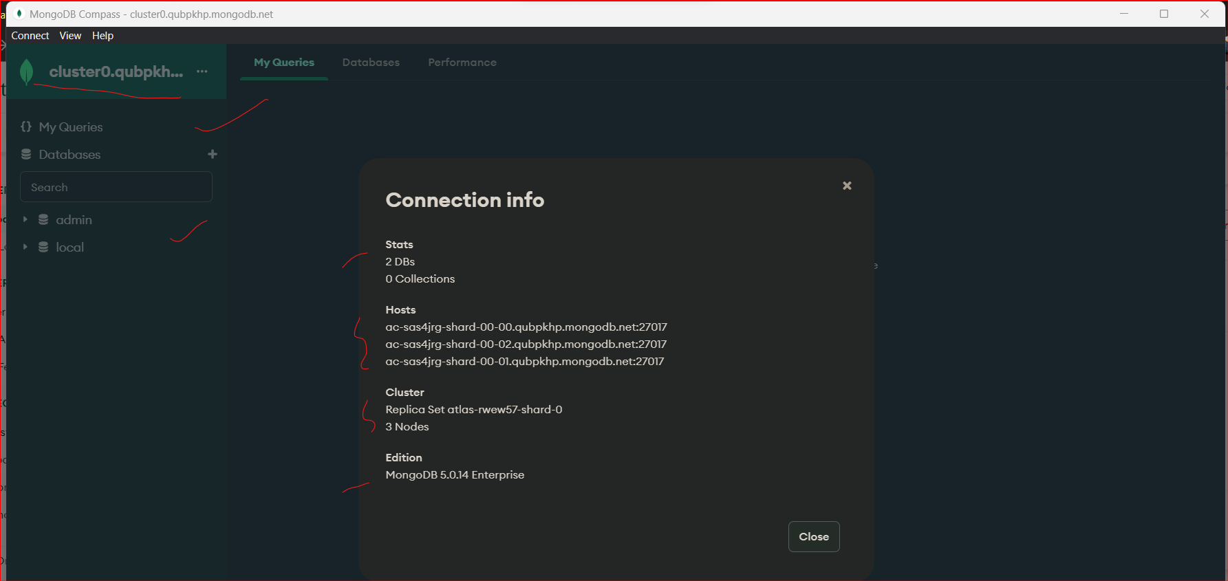

**So, 1 Cluster you have and Replica set of 3 Nodes**

**Inside a cluster there are 3 Nodes**

**So, We will connect this ATLAS connection string with Python, pymongo library MongoClient() connection**

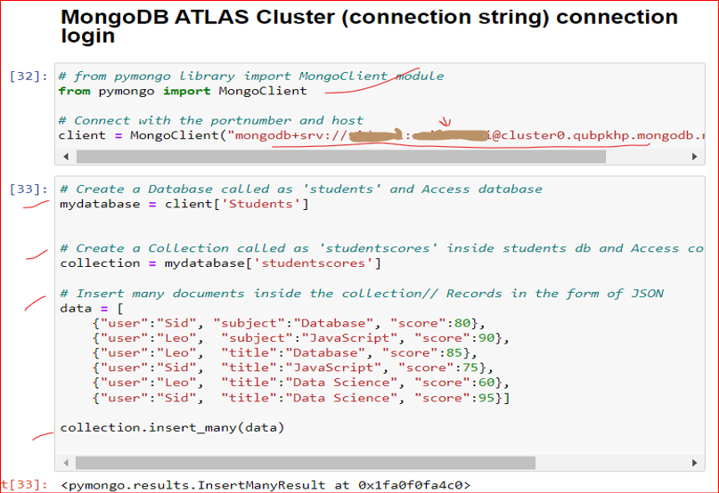

**Output:**

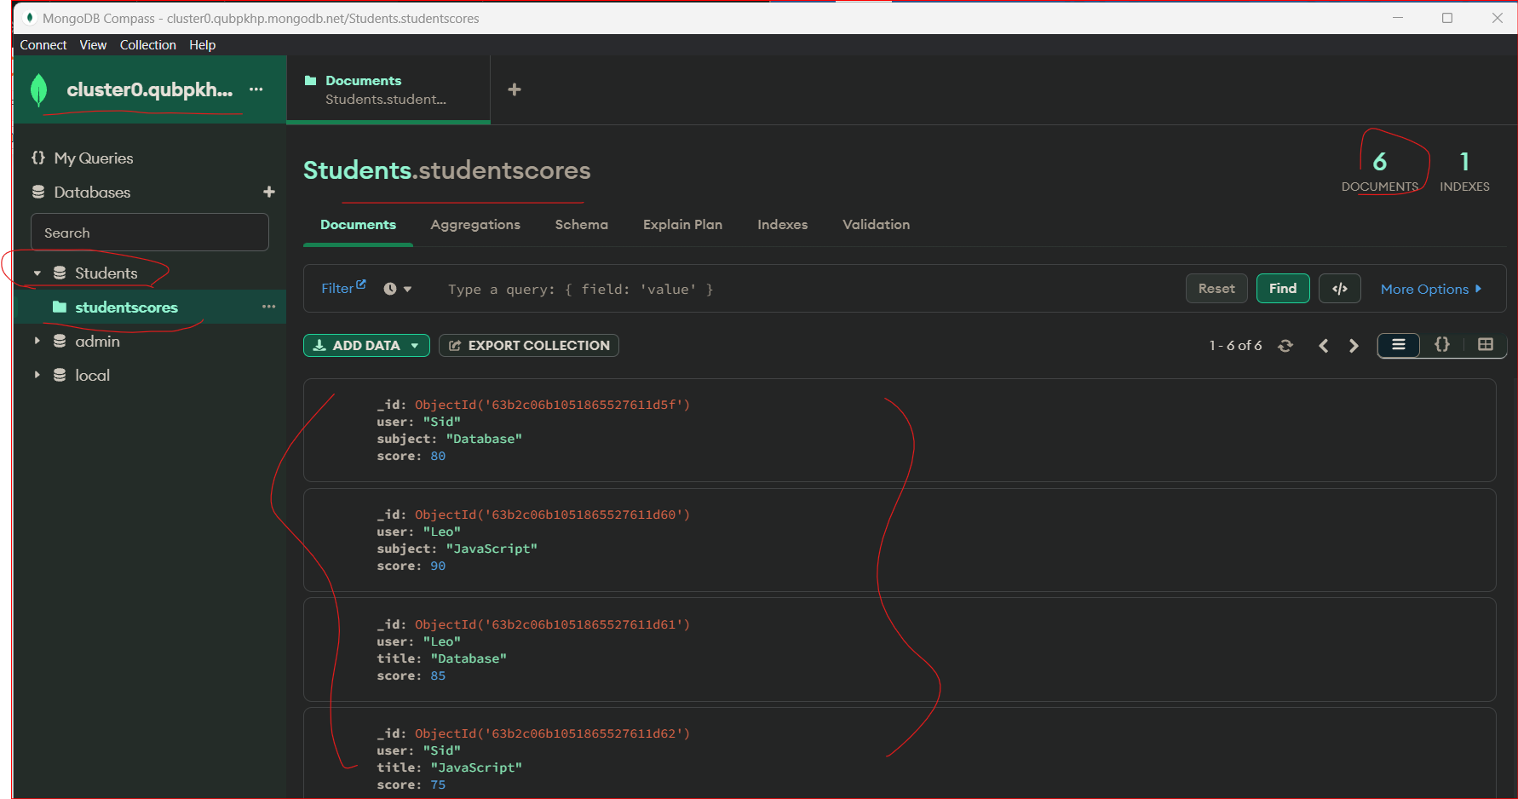

**MongoDB ATLAS Documentation:**

[**https://www.mongodb.com/docs/atlas/getting-started/**](https://www.mongodb.com/docs/atlas/getting-started/)